High Level Design (HLD)

HR Analytic Job Classification

Revision Number: 1.0

Last date of revision: - 29-04-2023

Pawan Nagar

# Document Version Control

|  |  |  |  |
| --- | --- | --- | --- |
| **Date Issued** | **Version** | **Description** | **Pawan Nagar** |
| **28th-April-2023** | 1.0 | First Version of Complete HLD | Pawan Nagar |
| 29-April-2023 | 1.0 | Final Version of Complete HLD |  |

**Contents**

Document Version Control 2

Abstract 4

1 Introduction 5

1.1 Why this High-Level Design Document? 5

1.2 Scope 5

2 General Description 5

2.1 Product Perspective & Problem Statement 5

2.2 Tools used 6

3 Design Details 7

3.1 Functional Architecture 7

3.2 Optimization 8

4 KPIs 9

4.1 KPIs (Key Performance Indicators) 9

5 Deployment 10

# Abstract

HR is not just about hiring people it is an ocean of its own. HR department goes through a constant journey of finding, selecting, onboarding and monitoring the right talent. You are required to use analytics concept to provide a smooth monitoring of workforce for the HR department. Job classifications reflect both job families and pay grade related information. This is especially relevant when new jobs are created which need to fit in the existing job structure. Jobs have a number of distinct features which impact the job’s classification. These include education level, experience, organizational impact, level of supervision, financial budget, and more. Knowing these factors for different jobs enables a job analyst to classify jobs into groups – which are connected to pay scales and benefit packages. Sundmark points out that Linear Discriminant Analysis (LDA) can be used to find combinations of features which characterize a number of classes of objects or events. Using LDA, Sundmark’s job classification data set can be used to classify newly created jobs in the existing job structure, providing guidelines for newly created functions

# Introduction

## Why this High-Level Design Document?

The purpose of this High-Level Design (HLD) Document is to add the necessary detail to the current project description to represent a suitable model for coding. This document is also intended to help detect contradictions prior to coding, and can be used as a reference manual for how the modules interact at a high level.

The HLD will:

* Present all of the design aspects and define them in detail
* Describe the user interface being implemented
* Describe the hardware and software interfaces
* Describe the performance requirements
* Include design features and the architecture of the project •
* List and describe the non-functional attributes like:

o Security o Reliability o Maintainability o Portability o Reusability o Application compatibility o Resource utilization o Serviceability

## Scope

The HLD documentation presents the structure of the system, such as the database architecture, application architecture (layers), application flow (Navigation), and technology architecture. The HLD uses non-technical to mildly-technical terms which should be understandable to the administrators of the system.

# General Description

## Product Perspective & Problem Statement

HR is not just about hiring people it is an ocean of its own. HR department goes through a constant journey of finding, selecting, on boarding and monitoring the right talent. You are required to use analytics concept to provide a smooth monitoring of workforce for the HR department. Job classifications reflect both job families and pay grade related information. This is especially relevant when new jobs are created which need to fit in the existing job structure. Jobs have a number of distinct features which impact the job’s classification. These include education level, experience, organizational impact, level of supervision, financial budget, and more. Knowing these factors for different jobs enables a job analyst to classify jobs into groups – which are connected to pay scales and benefit packages. Sundmark points out that Linear Discriminant Analysis (LDA) can be used to find combinations of features which characterize a number of classes of objects or events. Using LDA, Sun mark’s job classification data set can be used to classify newly created jobs in the existing job structure, providing guidelines for newly created functions.

## Tools used

Business Intelligence tools and libraries works such as Numpy, Pandas, Excel, R, Tableau, Power BI are used to build the whole framework.





# Design Details

## Functional Architecture

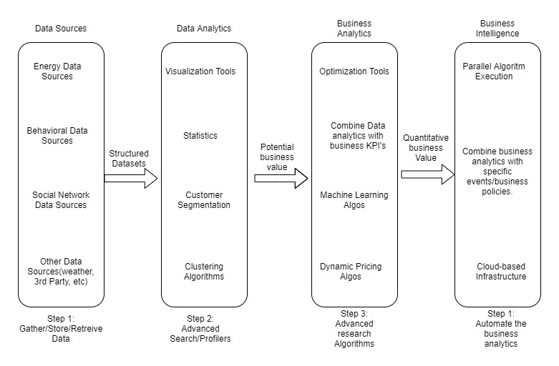

Figure 1: Functional Architecture of Business Intelligence

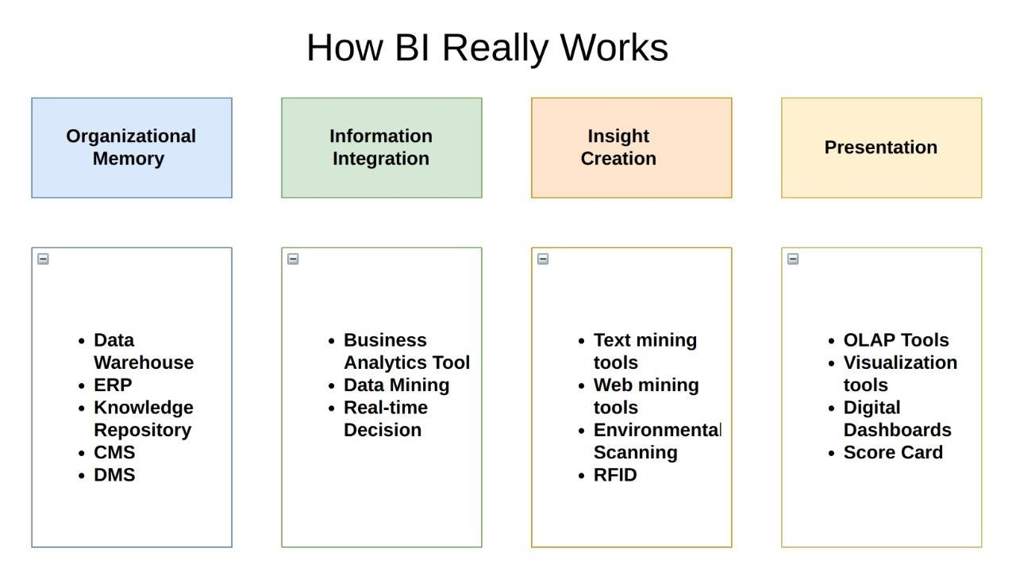

## Optimization

#### Your data strategy drives performance

* Minimize the number of fields
* Minimize the number of records
* Optimize extracts to speed up future queries by materializing calculations, removing columns and the use of accelerated views

#### Reduce the marks (data points) in your view

* Practice guided analytics. There’s no need to fit everything you plan to show in a single view. Compile related views and connect them with action filters to travel from overview to highly-granular views at the speed of thought.
* Remove unneeded dimensions from the detail shelf.
* Explore. Try displaying your data in different types of views. **Limit your filters by number and type**
* Reduce the number of filters in use. Excessive filters on a view will create a more complex query, which takes longer to return results. Double-check your filters and remove any that aren’t necessary.
* Use an include filter. Exclude filters load the entire domain of a dimension, while include filters do not. An include filter runs much faster than an exclude filter, especially for dimensions with many members.
* [Use a continuous date filter.](http://onlinehelp.tableau.com/current/pro/online/mac/en-us/help.htm#filtering_add_dragfields_dates.html) Continuous date filters (relative and range-of-date filters) can take advantage of the indexing properties in your database and are faster than discrete date filters.
* [Use Boolean or numeric filters.](http://www.tableau.com/learn/tutorials/on-demand/logical-calculations) Computers process integers and Booleans (t/f) much faster than strings.
* Use [parameters](http://onlinehelp.tableau.com/current/pro/online/en-us/help.htm#parameters.html) and [action filters.](http://onlinehelp.tableau.com/current/pro/online/en-us/help.htm#actions.html) These reduce the query load (and work across data sources).

#### Optimize and materialize your calculations

* Perform calculations in the database • Reduce the number of nested calculations.
* Reduce the granularity of LOD or table calculations in the view. The more granular the calculation, the longer it takes.
  + LODs - Look at the number of unique dimension members in the calculation.
  + Table Calculations - the more marks in the view, the longer it will take to calculate.
* [Where possible, use MIN or MAX instead of AVG.](http://onlinehelp.tableau.com/current/pro/online/windows/en-us/help.htm#calculations_aggregation.html) AVG requires more processing than MIN or MAX. Often rows will be duplicated and display the same result with MIN, MAX, or AVG.
* [Make groups with calculations.](http://kb.tableau.com/articles/knowledgebase/creating-groups-using-calculated-fields) Like include filters, calculated groups load only named members of the domain, whereas Tableau’s group function loads the entire domain.
* [Use Booleans or numeric calculations instead of string calculations.](http://onlinehelp.tableau.com/current/pro/online/mac/en-us/help.htm#functions_functions_string.html) Computers can process integers and Booleans (t/f) much faster than strings. Boolean>Int>Float>Date>DateTime>String

# KPIs

Dashboards will be implemented to display and indicate certain KPIs and relevant indicators for the disease.



As and when, the system starts to capture the historical/periodic data for a user, the dashboards will be included to display charts over time with progress on various indicators or factors

## KPIs (Key Performance Indicators)

Key indicators displaying a summary of the Housing Price and its relationship with different metrics

1. **Some Tiles for Quick Analysis**:

First tiles are representing total class.

Second tiles are representing total family.

Third tiles are representing type of education

1. **column and bar chart visualisation**: -

This chart is representing that PG and contact level

Bar chart are representing that job family and job description

1. **Chart Visuals**

First is chart are representing that PG and total job family

Second chart are representing that PG and total jobs.

1. **Education and Gread Based Analysis Visuals**

**First tiles are representing id and education level**

**Second tile are representing top 10 pay gread and family description**

# Deployment

Prioritizing data and analytics couldn’t come at a better time. Your company, no matter what size, is already collecting data and most likely analyzing just a portion of it to solve business problems, gain competitive advantages, and drive enterprise transformation. With the explosive growth of enterprise data, database technologies, and the high demand for analytical skills, today’s most effective IT organizations have shifted their focus to enabling self-service by deploying and operating Tableau at scale, as well as organizing, orchestrating, and unifying disparate sources of data for business users and experts alike to author and consume content.

Tableau prioritizes choice in flexibility to fit, rather than dictate, your enterprise architecture. Tableau Server and Tableau Online leverage your existing technology investments and integrate into your IT infrastructure to provide a self-service, modern analytics platform for your users. With on-premises, cloud, and hosted options, there is a version of Tableau to match your requirements. Below is a comparison of the three types:

TYPE PROS CONS

### Tableau Server - On Premises

* Full control of hardware and software
* Infrastructure and data remain behind your firewall
* Need dedicated administrators to manage hardware and software
* Additional infrastructure needed to access off-network (mobile, external)

### Tableau Server - Public Cloud (IaaS)

* Full control of software on managed hardware
* Puts infrastructure in same place as data (for migration to cloud)
* Flexibility to spin up/down hardware as needed
* Need dedicated administrators to manage software
* Additional infrastructure needed to access off-network (mobile, external)

### Tableau Online (SaaS)

* Fully hosted solution (hardware, software upgrades)
* Fast to deploy
* Easy for external audience to access
* Single-site in multi-tenant environment
* Cubes are not supported
* No guest account access

Depending on your organizational roles and responsibilities, Tableau Server should be installed by a systems administrator and the designated Tableau Server Administrator in coordination with the appropriate IT roles. For Tableau Online, you will integrate with your existing technology and configure the site settings. The Data & Analytics Survey, completed by business teams, identifies and prioritizes data use cases, audience size, and users. You will use the information collected in both surveys to plan your deployment strategy, including sizing, installation, and configuration of your Tableau Server or integration and configuration of Tableau Online. In addition to installing Tableau Server or configuring Tableau Online, administrators will also need to plan for the client software installation of Tableau Prep Builder, Tableau Desktop, Tableau Mobile, and Tableau Bridge for Tableau Online where applicable.